Practical - 11
Practical Title: Student Management CRUD with Search and Filter

Problem Definition: Create a student management module to add, view, edit, delete, search and filter student records. All database operations must use MYSQLi statements and clear success/failure messages.

Theory

Are SELECT, INSERT, UPDATE, and DELETE operations working?
Answer: Yes, full SELECT, INSERT, UPDATE and DELETE queries are implemented.

Is search by name/email/course implemented?
Answer: Yes, SQL LIKE conditions query records across student name, roll number, and email.

3. Are delete operations confirmed before execution?
Answer: Yes, JavaScript confirm() dialog prompts the user before sending the delete request.

Implementation/ Output/Result

Feature | Implementation
Create | INSERT query using MySQLi prepared statements.
Read | SELECT query rendering records in a table.
Update | Pre-fills form and runs UPDATE query.
Delete | Runs DELETE query with JS confirm() prompt.
Search and filter | Dynamic SQL LIKE and WHERE department = ?

Evidence of Work (Screenshots)

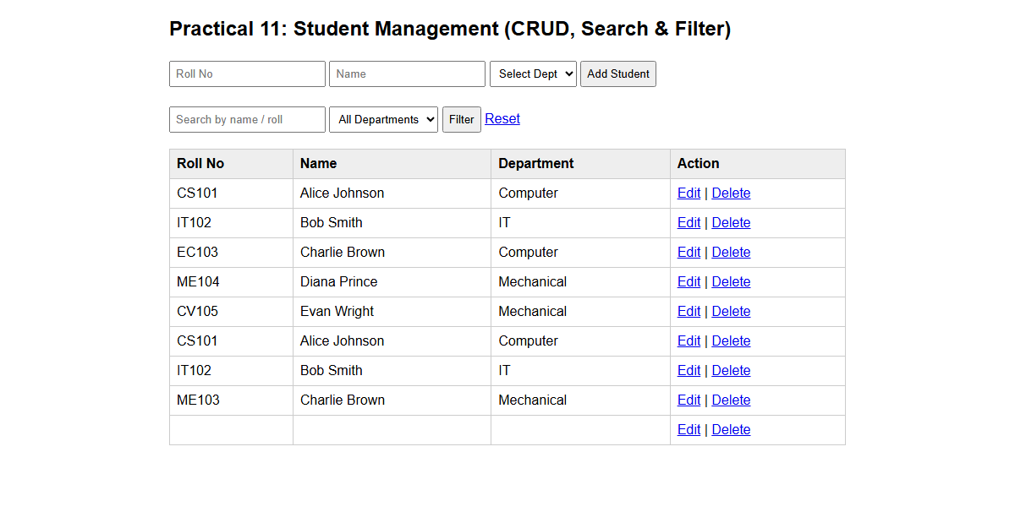
Description: Figure 11.1 records view

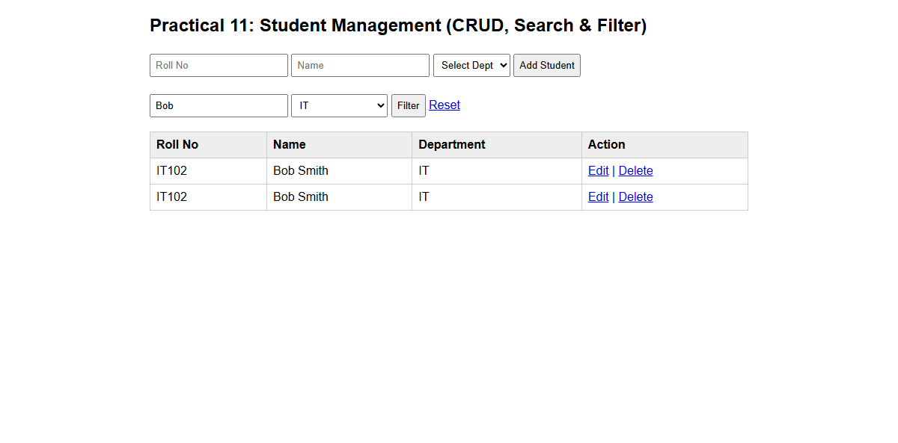
Description: Figure 11.2 search and filter

GitHub Repository Link:
Link: https://github.com/meetp2m/WDF-PRACTICAL-11

Challenges Faced:
Preventing SQL injection when combining multi-fields search conditions with dynamic filters.

Learning Outcome:
I learned how to develop a complete and secure data-mangement page.

Faculty Remarks:

